Chalk and Wire Directions
Teaching and Learning Excellence Center Revised Fall 2013

Submitting your Major Portfolio
research paper on Chalk & Wire
**If you have any questions, please email Molly Flavin (TLEChelp@principia.edu) or call her at extension 5143**

Step 1: Log On

- Go Chalk & Wire from the Prinweb (http://prinweb.prin.edu/collegemain.shtml).
- Enter your username (first/preferred name.last name—exactly the same as it appears in your Principia email address) and password.
- Click “Login.”

If you already have a “Writing Program (Phases)” Portfolio, skip step 2.

Click on your “GE Writing” portfolio and proceed to step 3.

Step 2: Create a New Portfolio
1. Highlight the “Work” dropdown menu at the top middle of the page, and click “My Portfolios.”
2. On the right hand side, click “Create New Portfolio.”
3. Enter the following name for your portfolio: “General Education Writing.”
4. Next, click “Can’t find your table of contents?”

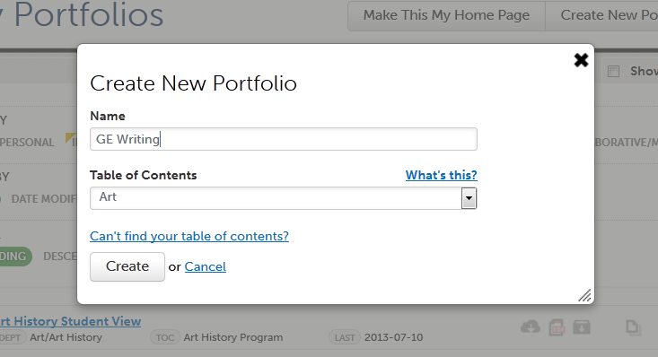
Select “General Education” as your department, and select “General Education Writing (GEW)” as your Table of Contents.
5. Click “Create.” This will take you to the page for the Table of Contents you have selected.

Step 3: Add Content to Your Portfolio

*Before you upload your file, make sure it is saved as a doc/docx or PDF
- On the menu on the left side of the page, find “Research writing,” and click on it. You have to click the assignment, so you upload your paper to the correct location.
- On the middle of the page, click the cloud button called “Upload New File” (see picture on the back for more guidance).

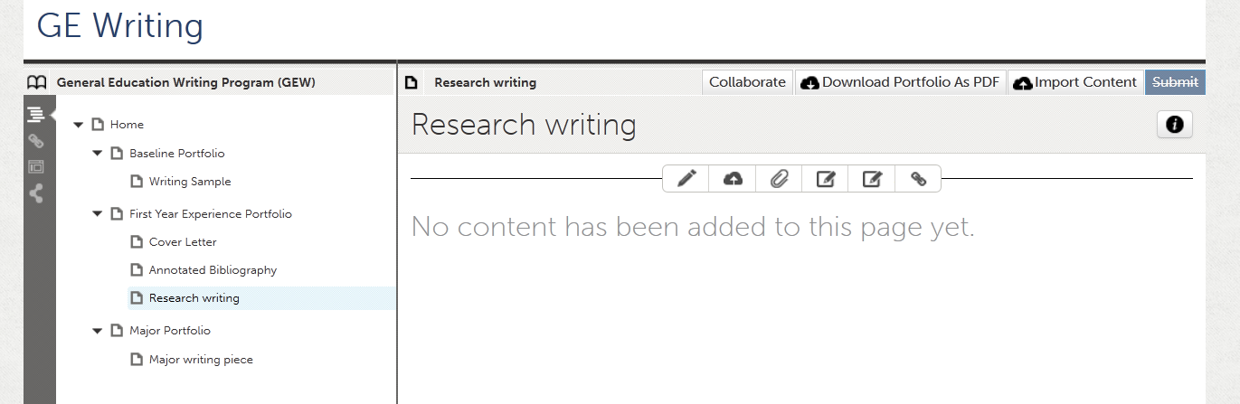
- This button will prompt another screen. Title the artifact with your first and last name and “Research writing” (ex. Molly Flavin Major writing piece). Skip about the “Keywords” or “Upload Options.” Click the “Upload File” button.

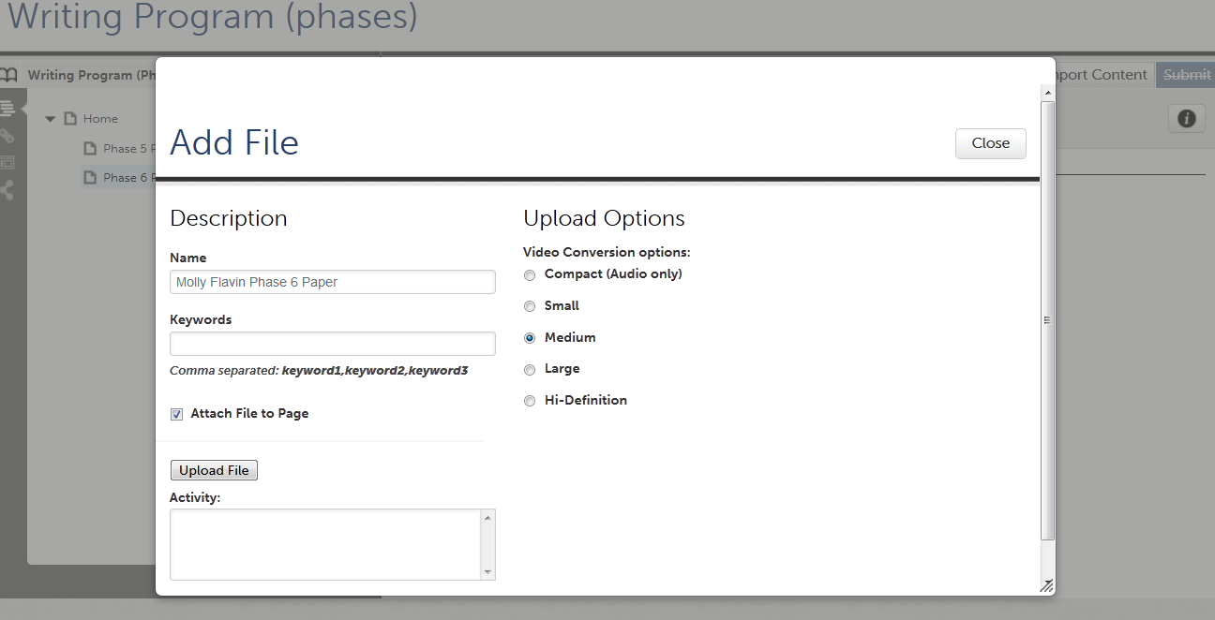
- Once the file has been uploaded, click “Save,” and then click “Close.” YOU ARE NOT FINISHED YET. The paper is on Chalk & Wire, but it still needs to be submitted. 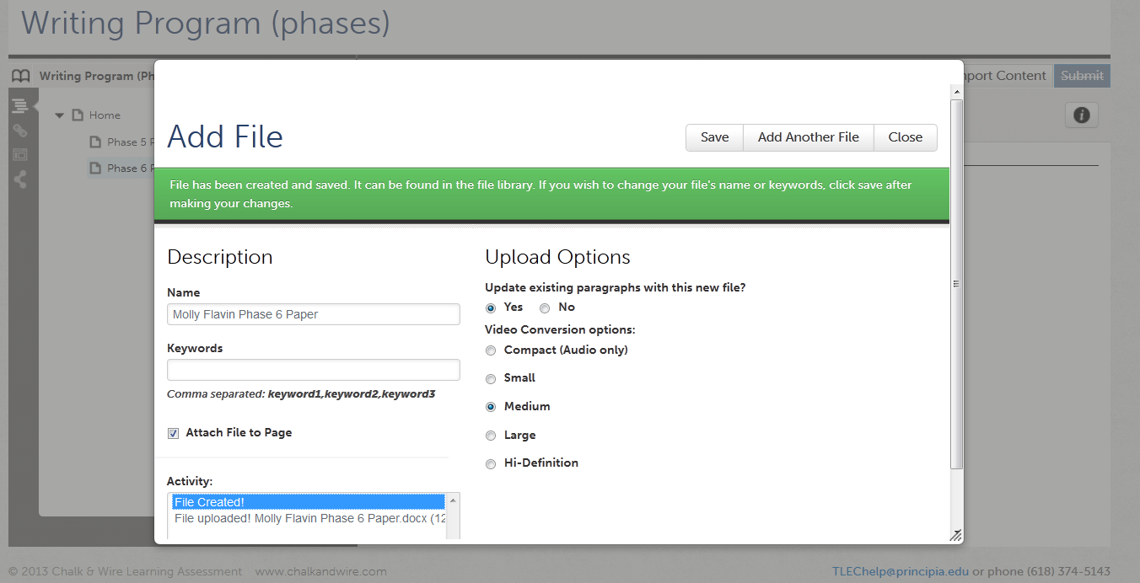
- On the far right side of the screen, click the blue “Submit” button. When asked to select an assessor for your paper, type the name of the professor of the class. As you start slowly typing the assessor’s name, a list of options will pop up and you can just click on the name. Then click “Submit.” You should see a green bar across the top of the screen with the message “You have successfully submitted” and a green box above that and to the right saying STATUS SUBMITTED. Congratulations, you are now officially submitted.

**If you have any questions, please email Molly Flavin (TLEChelp@principia.edu) or call x5143**

