Uploading Assignments to Chalk and Wire
Step 1: Login
https://ep3.chalkandwire.com/ep2_prin/
- Go to the Principia Chalk & Wire site:
Note: You can also access Chalk & Wire from the Prinweb (http://prinweb.prin.edu/collegemain.shtml).
- Enter your username (first/preferred name.last name—exactly the same as it appears in your Principia email address) and password.
- Click “Login.”
- From the “Work” tab at the top, click “My Portfolios.”

If you already have a portfolio for the department for which you are taking a course (i.e. History), skip step 2. Click on the department’s portfolio and proceed to step 3.

Step 2: Create a New Portfolio
1. On the right hand side, click “Create New Portfolio.”
2. Enter the following name for your portfolio. It should be labeled the department from the course you are taking. If you are taking HIST 252, then you should make a portfolio called “History.”
3. The Table of Contents will not be labeled correctly, so click “Can’t fine your table of contents?” (see picture below)

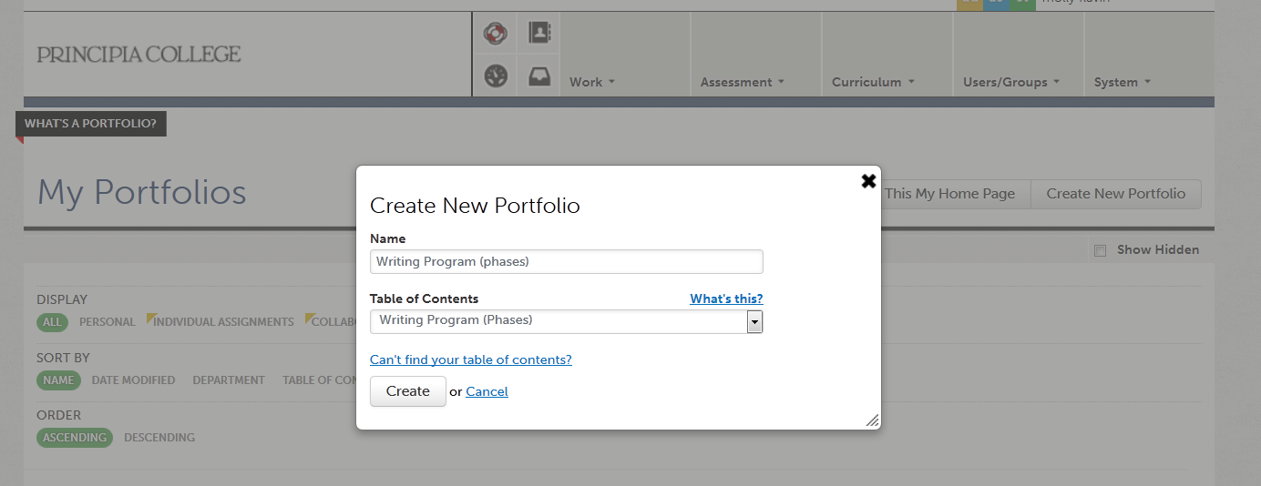

4. Use the drop down menus to find the correct department and table of contents for the course.
- Click “Create.” This will take you to the page for the Table of Contents you have selected.

Step 3: Add Content to Your Portfolio

*Before you upload your file, make sure it is saved as a doc/docx or PDF
- In the menu on the left side of the page, find the course name and number for the course you are enrolled in. Click on the specific assignment that you need to upload (ex. HIST 252 research paper).

- Once you click on the assignment, look on the right side of the page to find a cloud button called “Upload New File.” Click on this button to upload your assignment.

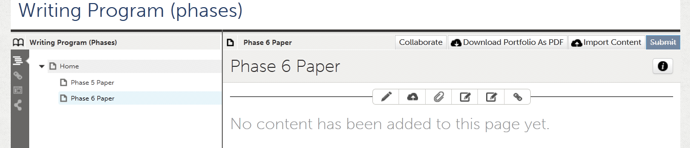
- This button will prompt another screen. Title the artifact with your first and last name and the phase you are submitting (ex. Molly Flavin Research Paper). Do not worry about the key words. Click the “Upload File” button.

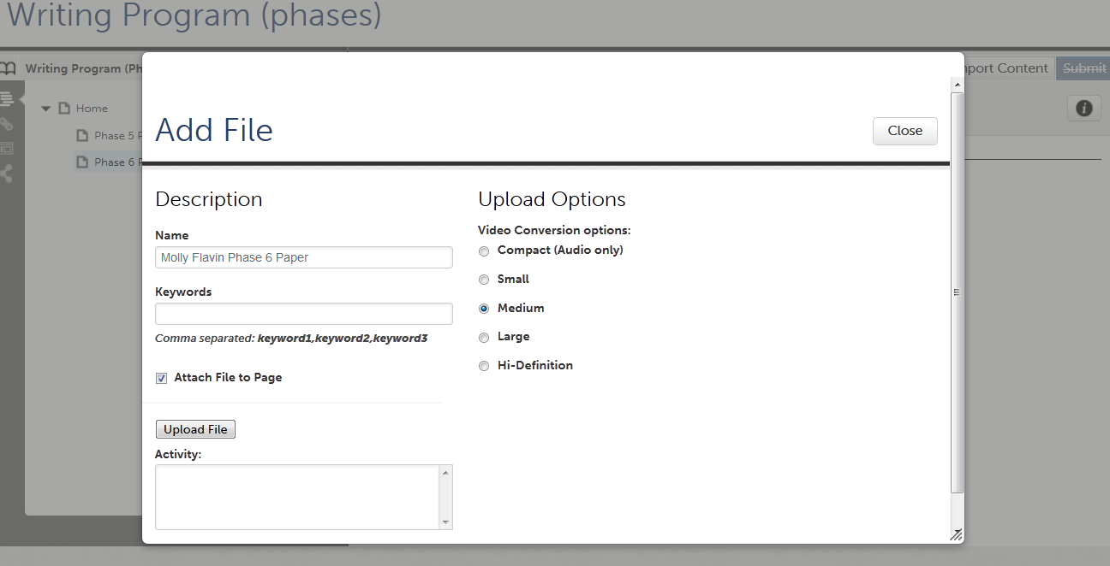

- Once the file has been uploaded, click “Save,” and then click “Close.” YOU ARE NOT FINISHED YET. The paper is on Chalk & Wire, but it still needs to be submitted.

- On the far right side of the screen, click the blue “Submit” button. When asked to select an assessor for your paper and/or assignment, type the name of the professor who taught your course. As you slowly type your professor’s name, a list of options will pop up and you can just click on the correct name. Click “Submit.” You should see a green bar across the top of the screen with the message “You have successfully submitted” and a green box above that and to the right saying STATUS SUBMITTED. Congratulations, you are now officially submitted. Don’t forget to log off and close your web browser.

